COCO-FLASH PROGRAM MANAGER USER's GUIDE
=========================================

The program DFEM (Dragon Flash Eeprom Manager) has been developed by Pere Serrat and published on February, 2018
The version used to write this manual is v1.4U

To see more information about the Program/Device, please, read the document
DFEM-Description.txt

I N D E X

Section Page
-------------------------------------------------------
1 - MAIN MENU SCREEN 2
1.1 - SPECIAL FUNCTIONS 3
2 - PROGRAM MANAGEMENT 6
2.1 - ENTERING A NEW PROGRAM 7
2.2 - DELETE A PROGRAM 12
3 - CATEGORY MAINTENANCE 14
4 - ATRIBUTES MANAGEMENT 16
4.1 - CATEGORY ASSIGNEMENT 17
4.2 - HOTKEY ASSIGNEMENT 18
4.3 - PROGRAM PROTECTION 19
5 - LOADING CHUNKS/PROGRAMS 20
1 - MAIN MENU SCREEN

When we start the Dragon while pressing the button on the Flash module to avoid auto-starting of the embedded DOS, you will see for a short while the DP50E message on the screen and immediately it will load and exec the DFEM, so the first screen will be this one.

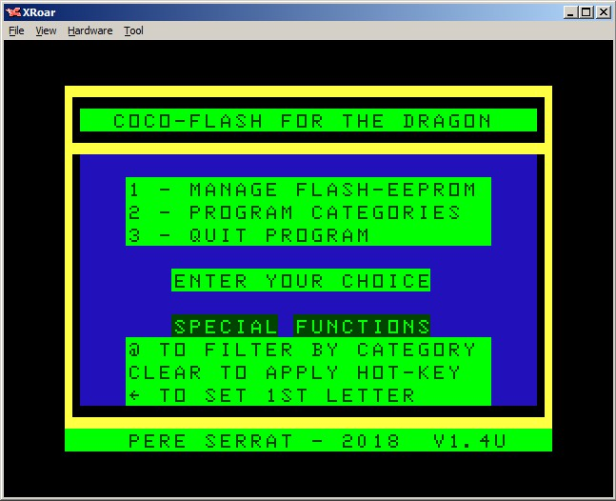

Here we find some "SPECIAL FUNCTIONS" information
- '@' can be used to filter the programs shown to see only the chosen category ones
- The 'Clear' Key allows to exec/run a program just by typing its associated hotkey
- 'Left cursor' allows the user to choose the first letter of the programs to be shown.
In this case this is not a filter, but a positioning aid. You will see all the programs whose first letter is equal or greater than the chosen one.
To see how these options work, see point 1.1

The menu options we have here are

'1' to go to the Program Management screen, see point 2

'2' to see/modify Category descriptions, see point 3

'3' to quit and go back to the Interpreter/DP50E

  - - SPECIAL FUNCTIONS

- If you filter by category, the chosen letter will be shown above the header of the column for Category. Pressing '@' will show

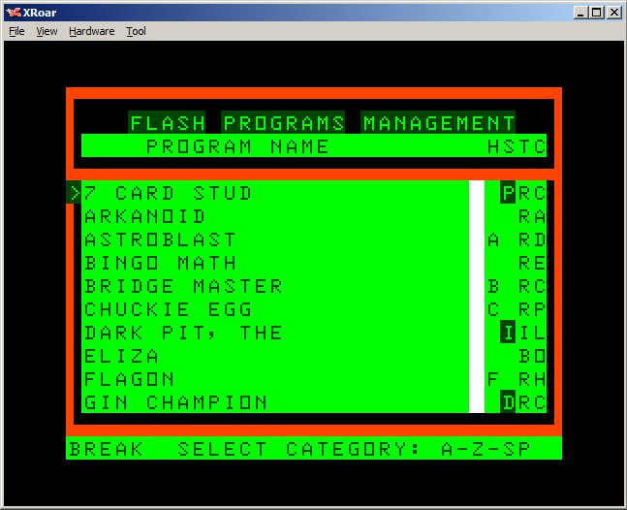

And now choosing category 'C' would show this

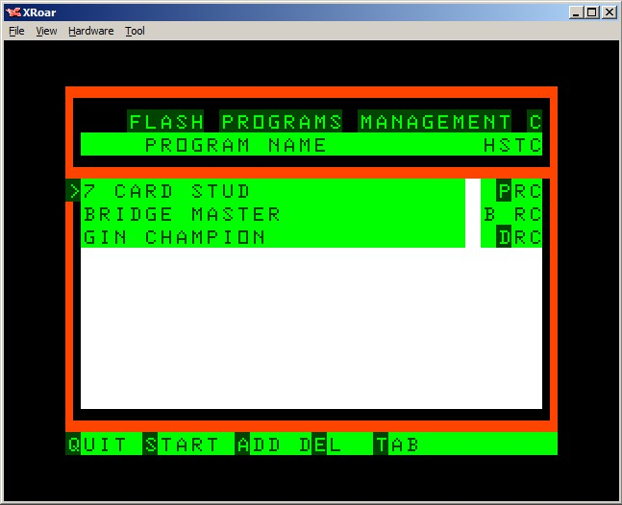

When choosing category, if you press SPACE, it cancels the filter, so you will see again all the programs.
- If you select any first Letter for positioning, that will be shown above the program name at the top left. Pressing 'Left Cursor' shows

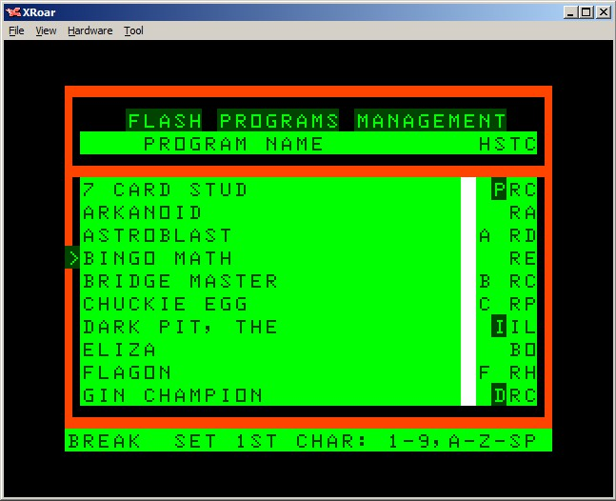

Choosing a number or a letter will show all the programs that begin with a letter equal or greater that the entered one. I chose 'D'

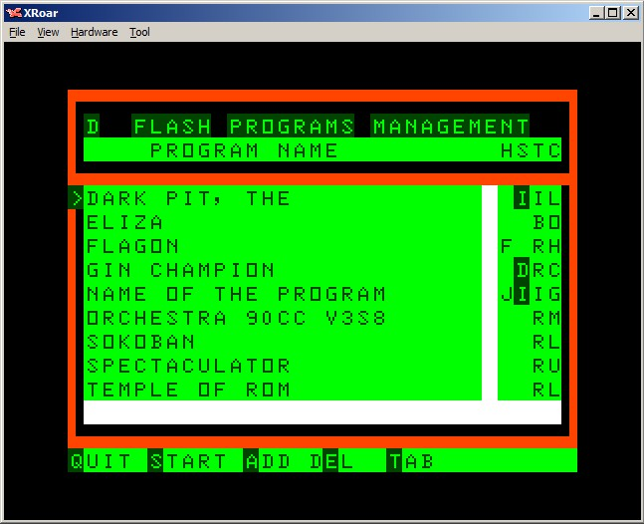

Again, pressing space instead of a sign, will cancel the positioning and the program will show all the programs again

- If you press 'Clear' to call/exec/run a program, you will see

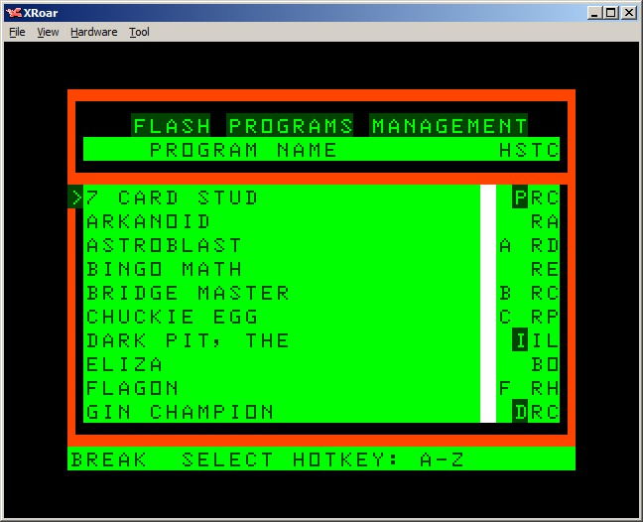

Here we are allowed to enter any key, no need to be 'seeing' the desired program.

All of these 'special functions' can be used on the "Program Management" screen. If we are on the "Attributes" screen, then the HotKey is not allowed.

2 - PROGRAM MANAGEMENT

This is the info I entered (some 14 programs. We see 10 per screen page)

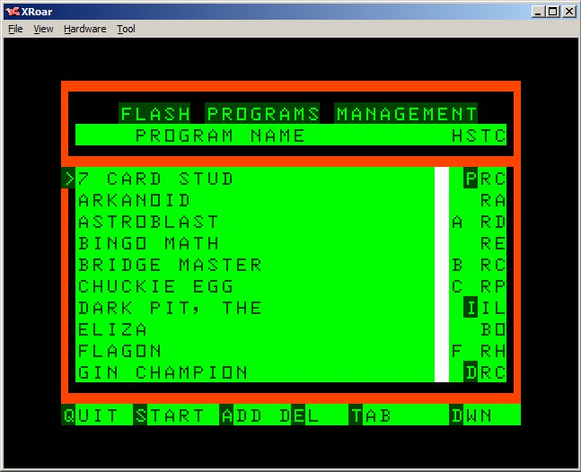

This is a list of programs with their attributes
On the right part of the screen, we see
Under 'H' we see the associated Hot-Key if any
Under 'S' we see the program status, which can be:
- space for 'normal' program
- Inverted 'D' for Deleted program
- Inverted 'P' for Protected program
- Inverted 'I' for Incomplete program
Under 'T' we see the program type. This accepts four different values
- 'R' for auto-start ROMs
- 'N' for non auto-start ROMs
- 'I' for Binary programs
- 'B' for Basic programs
Under 'C' we see the associated Category if any

The bottom row shows the available options
'Q' - goes Back to previous menu
'S' - Start/Exec/Run the selected program
'A' - Allows Adding a new record to the list, see point 2.1
'E' - Allows Deleting/Undeleting the program, see point 2.2
'T' - Switches to the Atributes screen, see point 4
'U' - Previous data page (page up if applicable)
'D' - Next data page (page down if applicable)

We use here the cursor arrow keys Up-Down to move the cursor. These two have auto-repeat function added and will not roll to next/previous page.

2.1 - ENTERING A NEW PROGRAM

After having chosen the 'A' option, we see that on screen

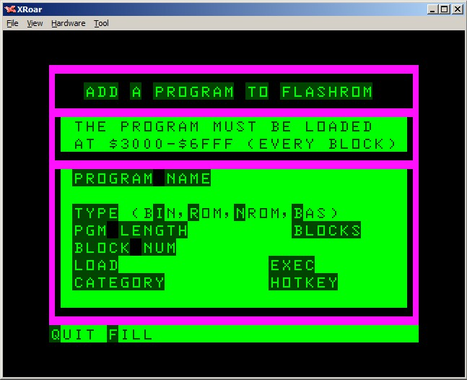

Here we can choose
'Q' to go back to previous screen
'F' to fill the data form for a new program or the second part of a program

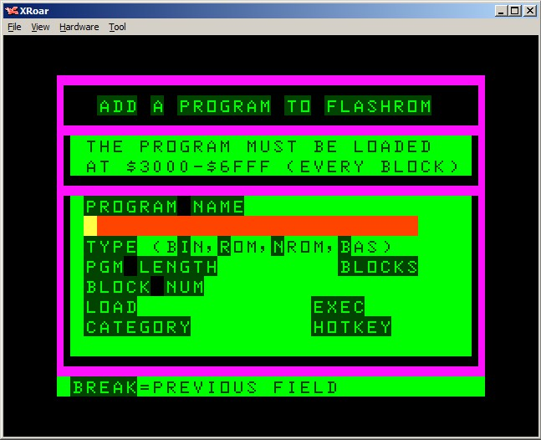

The row for the Filename is in red colour and the cursor is a yellow block
We can enter letters and numbers and user backspace to correct errors.
After entering 25 chars or pressing enter (one char minimum) we see

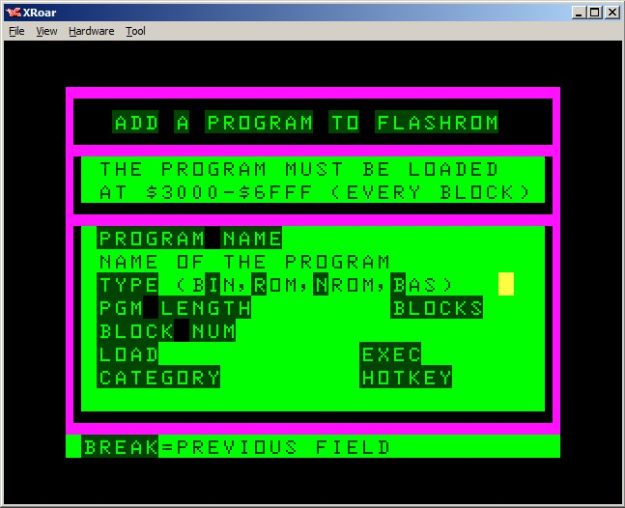

Now we must enter the Type of program, let's assume binary (‘I’)

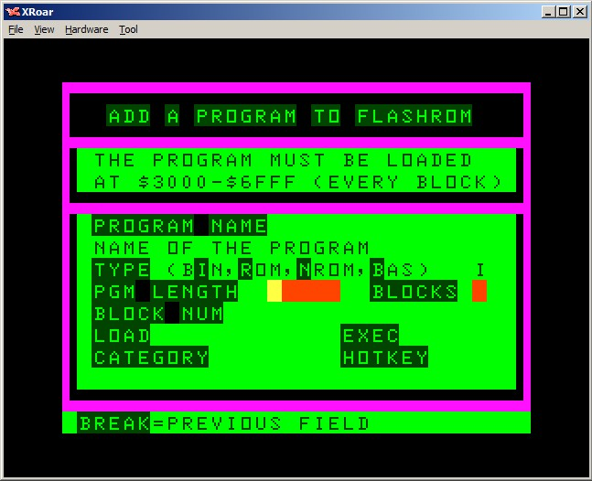

We will enter the Length in decimal numbers and the Blocks field will be calculated by the program. It will be 1 if length is less or equal to 16384, else it will be 2. The program length cannot be greater than 32600 bytes
The next screen after entering the program length will be

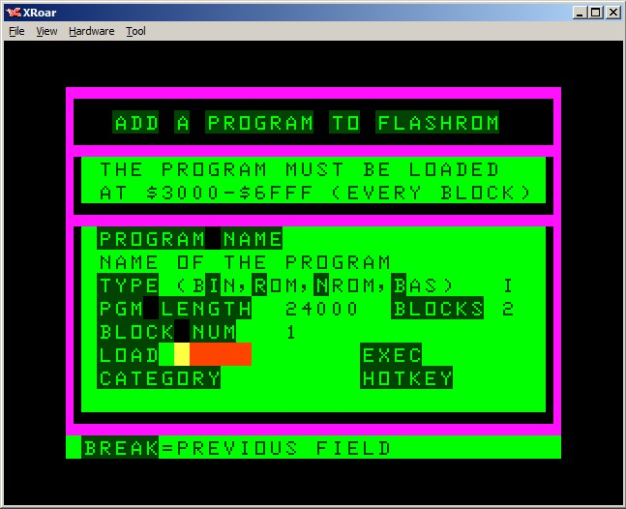

Now we can enter the Load address, which has to be low enough to allow to load the length into the lower 32 Kbytes of RAM, say that the start cannot be higher than 8560. In this case next screen is

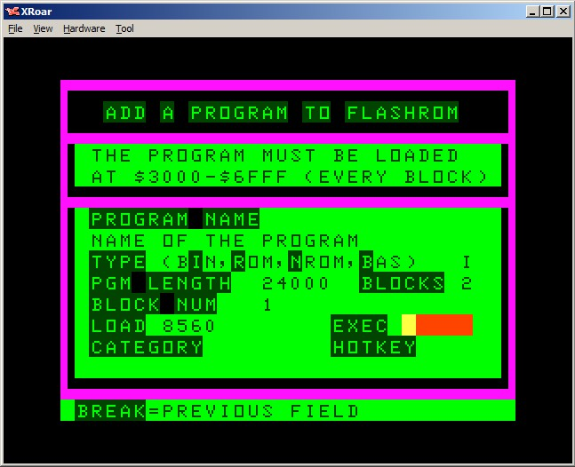

Now we enter the Exec address, which cannot be lower than the Load address.

Once we enter that Exec address, the program will show us the Category select screen where we can go up-down to search for the category we would like. If we don't want to assign any, we just press '0'.
In case we press 'Break' we will go back to previous screen (to enter the Exec address). I chose 'G' in this case
Then we see the HotKey selection screen with the same options.
W can choose one or simply press '0' to go on without any Hotkey selected.
I chose 'J' here, so the final screen is

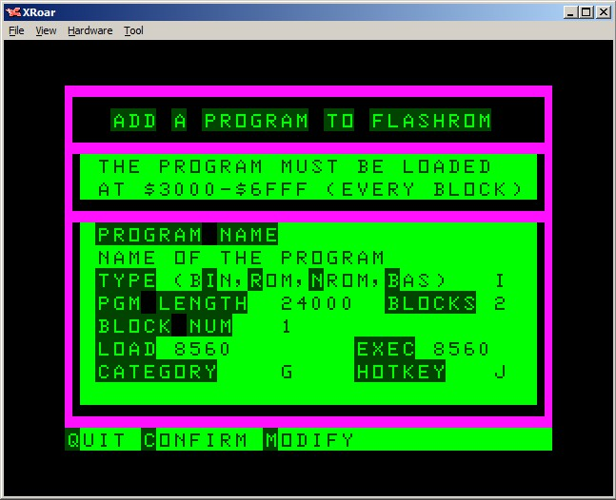

Here we should verify that all the entered data is correct and then we press
'C' to confirm and flash the 16k chunk or we could as well press
'M' to modify any wrong field. In this case the program will go back to the last entered field (HotKey selection) and pressing Break further it will send us to previous fields ...
Pressing 'Q' would abort the process losing all the entered data.

*** NOTE 1 ***
When we enter the second chunk of data for a long program, once we are in the screen to Fill the relevant data, we *just* need to enter the Filename, exactly as we did for the first block. Then the program will fill all the other fields and will wait for the user to choose between 'Confirm' and 'Quit'

*** IMPORTANT ***
We must be sure that before entering data here, we have loaded the program into RAM at positions $3000-$6FFF, else we'd better press 'Q' and go load it. The procedure can be seen in point 5.
After confirming, the program will flash the chunk we had previously loaded and will create a record in the EEPROM database, showing that the record is incomplete in case the length was greater than 16k, so we should load the second part of the program later ...
Remember that if we create an entry for a program bigger than 16k file (Binary or Basic), when we enter the first chunk of 16k, the program will reserve the total space in flash and will remember us that we have only entered the first part. No action can be applied to incomplete files other than completing them.
After pressing Down once to see next screen, that's what we will see

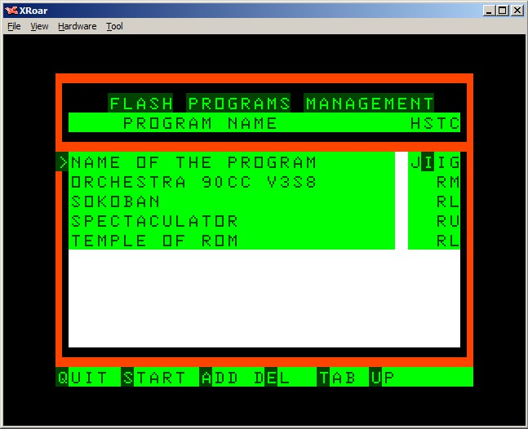

*** NOTE 2 ***
Some fields will be calculated by the program in cases like Basic and ROM, because some of them are fixed by the system

2.2 - DELETE A PROGRAM

If we don't want to allow a program to be started, then we can mark it as 'deleted'. We do that pressing the DEL option ('E' key) and confirming later.
If we press DEL on an already deleted program, we could 'undelete' it too.

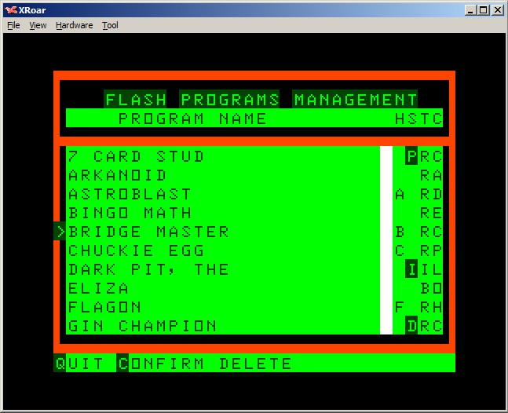

Here we can only choose between two choices
'Q' to go back to previous screen
'C' to apply that change. This will be shown with the inverted 'D'

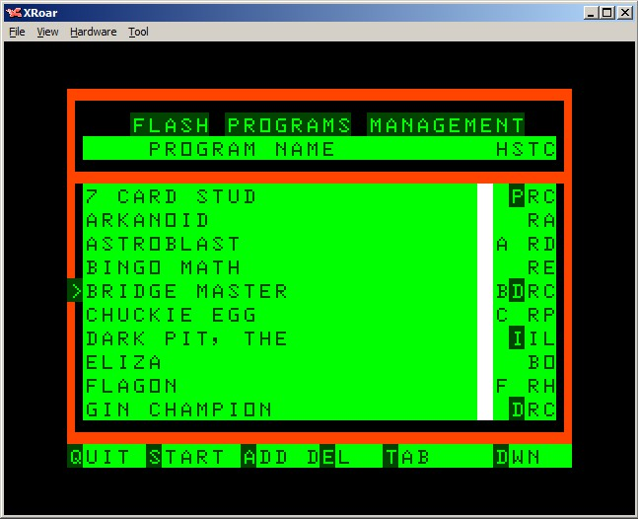

If we choose this option on an already 'deleted' file, we'll see this

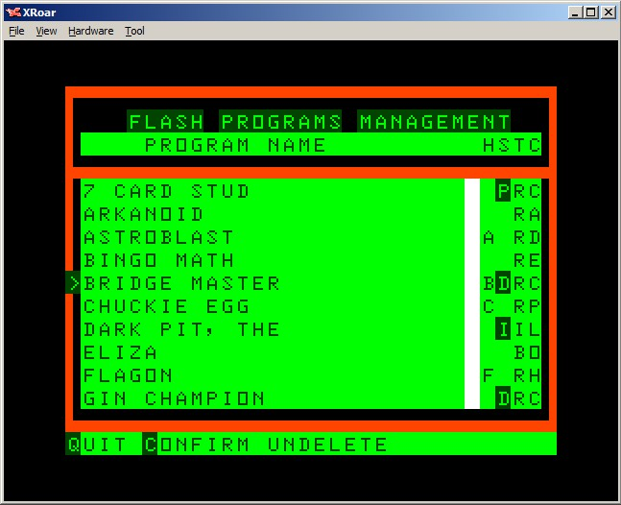

If we confirm here, the program will be shown without the inverted 'D' so we have 'undeleted' that program.

3 - CATEGORY MAINTENANCE

The categories are shown 10 per page and entering a letter allows the user to assign whatever description he wants to that letter/category

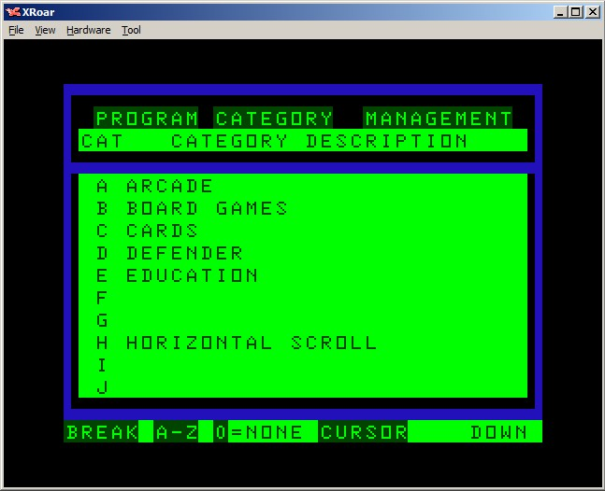

On the bottom row we see the available options
'Break' - - - - - - - - - - - - - - - - Back to previous menu
'0' - - - - - - - - - - - - - - - - - - - No letter, so back to previous menu too
Cursors UP-DOWN (if possible) - Paging options
Letters 'A' to 'Z' - - - - - - - - - - - User can input text for that entry

This screenshot shows the screen after pressing letter 'G'

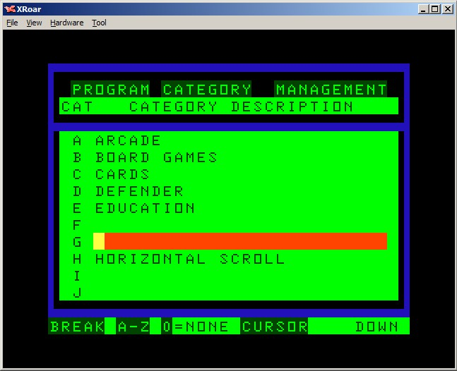

Next screenshot shows that each description can be 26 chars long

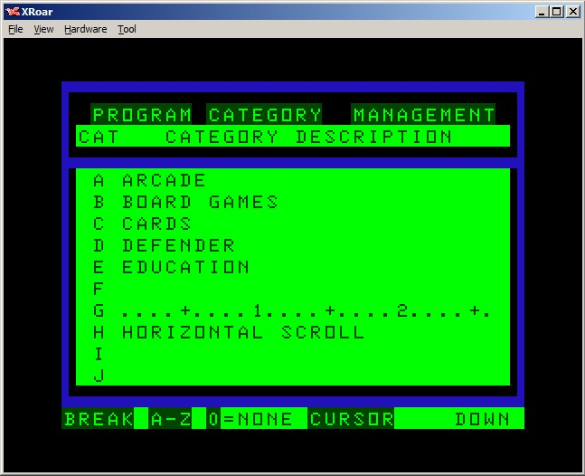

4 - ATRIBUTES MANAGEMENT

This screen has the same info that we can see in the "Program Management"

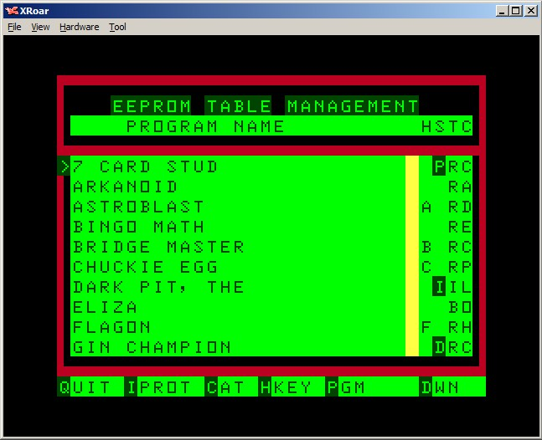

The main differences are the colours used and the footer option.
The available options here are
'Q' - Back to main menu
'C' - To assign/unassign a Category to a program, see point 4.1
'H' - To assign/unassign a HotKey to a program, see point 4.2
'I' - To protect/unprotect a program, see point 4.3
'P' - Switches to "Program Management" screen
'U' - Previous data page (page-up if applicable)
'D' - Next data page (page-down if applicable)
A few restrictions apply:
- An 'Incomplete' file cannot be modified (any attribute)
- The same applies to 'Protected' and 'Deleted'
- The 'Deleted' files cannot be 'started/exec/run'

4.1 - CATEGORY ASSIGNEMENT

If we press 'C' to assign a Category, the program will show us the list of categories so that we can choose one

We can page up-down to search for the desired category and then press that letter. Only the letters that appear on the screen are eligible.

4.2 - HOTKEY ASSIGNEMENT

If we press 'H' to assign a HotKey, the program will show us the list of hotKeys so that we can choose one

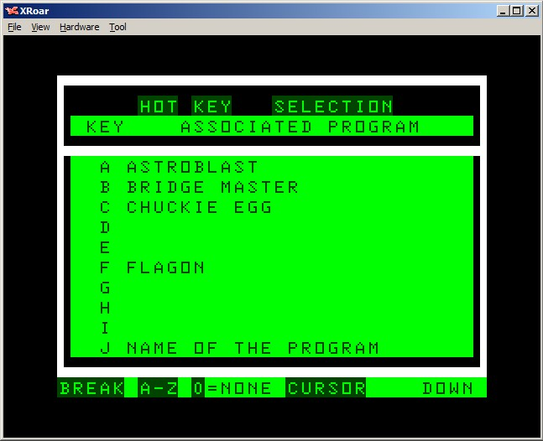

We can page up-down to see the desired hotkey and then press that letter.
Only the letters, not yet in use, that appear on the screen are eligible.

4.3 - PROGRAM PROTECTION

If we want to disable Attribute changes for a program, we 'Protect' it, if we press the Protect command ('I') on a protected file, we could Unprotect it too.

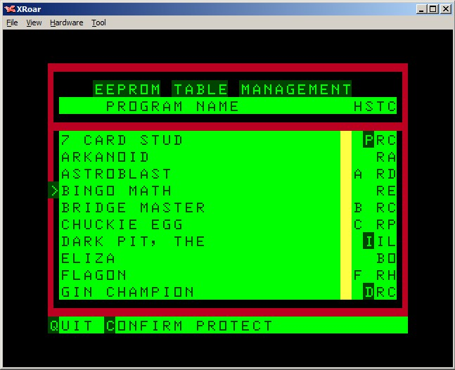

We can 'Confirm' or 'Quit' that screen
In case we press 'I' on an already protected program, we would see

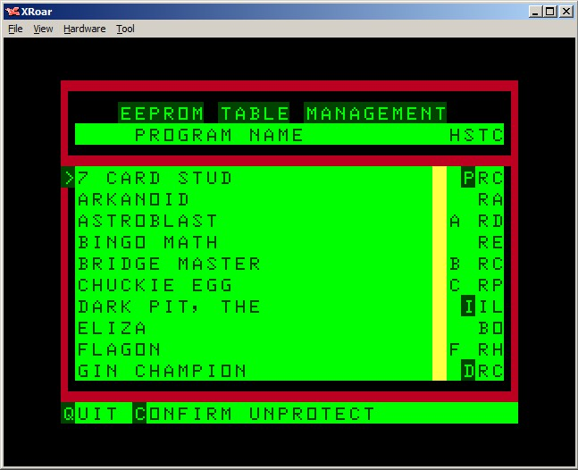

With the same options we had in previous example

5 - LOADING CHUNKS/PROGRAMS

By now I have been using Drivewire to take advantage of the function LROM that I added to the DP50E.
As we are in the main screen of the DFEM, we have to quit the program pressing '3'to go back to the Interpreter.
Now we should load a program to be flashed (or the first chunk of a long one)
Entering LROMN"ROMNAME" will load it at $3000-$6fff
Don't forget the N after LROM or the ROM will be started ...
Once loaded, we enter again to the DFEM issuing
EXEC&H1400
Then we press '1', 'A', 'F' and fill the necessary data for the loaded program
To help users, I created a Java program that creates an output file with the name of all the binary/basic programs inside a folder listing for each one its Type, Load address, Length and Exec address.
Once Confirmed, the program will be flashed and we must Quit the program to load the second chunk or another program, so we press
'Q' and '3' to exit to Interpreter and load another program/chunk
Using this procedure requires that we create the ROM files from the binary/basic programs
The files must have ROM extension to be loaded correctly, so NO header at all.
- For ROMs there is no problem, they do not have any header
- For the other formats (BIN, BAS) which can be even longer than 16k, we need a tool that can 'cut off' the header and create one or two files, as needed.
I created a small Java program that creates the needed .ROM files to be loaded later, it adds -R1 and -R2 to the file name. We must always flash first the R1 part, later we will add the -R2 part

The DP50E has the command DWLOAD"NAME" that will allow to load/execute any binary from the DW4server we want to exec, for instance the 'tools' I have added to the pack or any other DW4 program.

